Note 07 – Example

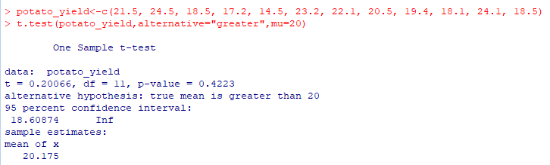

Hypothesis:

H0: µ ≤ 20; (potato yield from farm is not significantly better than 20)

H1: µ > 20; (potato yield from farm is significantly better than 20)

p-value > α = 0.05

Therefore, H0 is not rejected.

The potato yield from these farms is not significantly better than 20.